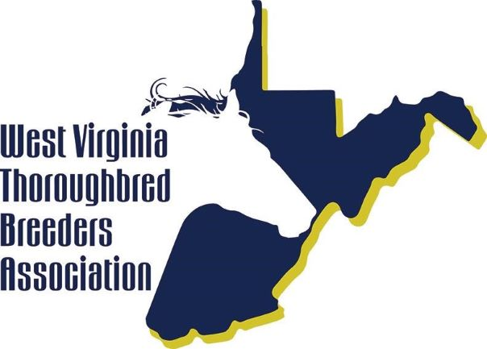
STALLION APPLICATION Year _______

West Virginia Thoroughbred Breeders Association, Inc.
P.O. Box 626, Charles Town, WV 25414
Phone: (304) 728-6868 Fax: (304) 724-7870
Website: www.wvtba.com Email: wvbreeders@gmail.com

☐ $150 (Annual Renewal) ☐ $250 (Original Registration) ☐ $300 (Late Renewal)

Make all checks payable to West Virginia Thoroughbred Breeders Association (WVTBA). Payments must be made before Stallion covers 1st mare of the Season. In any case, renewal forms postmarked after March 1st is $300.00. Renewals must be filed every year for a stallion to maintain eligibility in the WVTDF program.
NOTE: A copy of the Stallion's Report of Mares Bred for the previous season MUST be supplied with annual renewals.

Name of Stallion: ______________________________________________________________ Year Foaled: _______________
Sire: _____________________________ Dam: _________________________________ Sire of Dam: _________________________
Year Entered Stud: ________________ Year Mares First Covered In WV: ___________________________
Farm where horse Is going to stand in WV: Farm contact: ________________________
Address: ___________________________________________________________ Phone: ______________________________
Stallion Owner: _________________________________________________________________________________________
Address: ______________________________________________________________________________________________
Email: __________________________________________________________________ Phone: _____________________________
Years of Ownership: __________________
Syndicate Manager (If applicable): ___________________________________________________________________________
Address: __________________________________________________________________ Phone: ______________________
Email: _________________________________________________________________ Phone: _____________________________ If stallion previously stood in another state, list years stood and any previous owners: ________________________________________
Stallion bonuses will not be paid unless the stallion is properly registered with the West Virginia Thoroughbred Breeders Association (WVTBA) as an accredited West Virginia Stallion.
Any change of ownership or stallion location must be reported to the West Virginia Thoroughbred Breeders Association in writing as they occur. Stallions that are unavailable for Inspection will be considered to have left the state unless otherwise noted by the WVTBA.

By signing below, I certify that all the Information given above is true and correct, and further that I understand that in the event of falsification of any of the above Information, I shall be subject to sanctions to the full extent of the authority of the West Virginia Racing Commission.

_____________________________________________________ ___________________________
Signature of Applicant Date

For Office Use only:

Date paid: ___________________ Check #: ______________ Amount: _____________ Member dues paid: ____________________

West Virginia Stallion Requirements
WV Thoroughbred Rules of Racing 2.2. "Accredited West Virginia sire" means a sire that is permanently domiciled In West Virginia, stands a full season in West Virginia, and Is registered with the West Virginia Thoroughbred Breeders Association.
Sire Owner bonuses will not be paid unless the stallion is properly registered with the West Virginia Thoroughbred Breeders Association (WVTBA) as an accredited West Virginia Stallion. Original registration with the WVTBA must be made before the Stallion covers his first mare of the season. Annual renewals must be postmarked before March 1st every year thereafter with a copy of the report of mares bred for the previous breeding season. Late penalties of double the regular fee will apply for any late registration. Stallion owner listed on stallion registration form will be the one to receive WVTDF sire owner bonuses. If there are multiple owners, one person must be specified and agreed to in writing by all Involved parties. Any agents or managers for the stallion must also provide written proof that they are responsible for and agreed to by the owner/owners of the stallion.
Stallion must be permanently domiciled in the State of West Virginia to receive stallion bonus awards from the West Virginia Thoroughbred Development Fund. Residency will be verified by the Development Fund Inspector. Stallions moved from the State cannot return and stand under the same ownership, but may continue to receive bonuses on eligible progeny running in the State as long as renewal payments and registration are made to the WVTBA. Reinstatement of a stallion returning to West Virginia under new ownership must provide an original stallion contract to the WVTBA. Annual renewals must be filed by March 1st each year to remain eligible for WVTDF sire owner bonuses. Stallions that are unavailable for inspection will be considered to have been removed from the state unless the WVTBA has been previously notified.
Stallions sold or moved out of the state, the owner must report in writing the date the stallion physically left West Virginia and the destination. If moved out of the state during the breeding season (prior to July 31), NO stallion bonuses will be paid for foals conceived that year. Stallions moving into or out of West Virginia during the breeding season CANNOT collect stallion bonuses if they have covered mares during the same season in another state. Annual renewals are required to receive sire owner bonuses.
Any change of ownership or stallion location must be reported to the WVTBA in writing as they occur.
Deceased or gelded stallions: Date of death or veterinary report of castration must be reported to the WVTBA, in writing, prior to February 1st of the following year. No renewal payments are necessary. Bonuses will be paid automatically after the report has been received. However, for the Supplemental Purse Award program (formerly 10-1010) this does not apply. Forms for the Supplemental Purse Award must be filed separately with the West Virginia Racing Commission.
Please contact the WVTBA with any questions regarding stallion requirements or eligibility. Please refer to WV Code (§19-23-13b West Virginia Thoroughbred Development Fund; distribution; restricted races; non-restricted purse supplements; preference for West Virginia accredited thoroughbreds) for rules and regulations of the WV Thoroughbred Development Fund.

