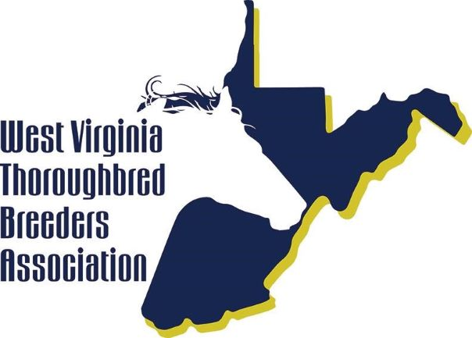
RESIDENT MARE FORM Year _______

West Virginia Thoroughbred Breeders Association, Inc.
P.O. Box 626, Charles Town, WV 25414
Phone: (304) 728-6868 Fax: (304) 724-7870
Website: www.wvtba.com Email: wvbreeders@gmail.com

The following form is to be completed by mare owner or farm manager for all mares that reside at your farm year-round regardless of the owner's residency status. It is to be done on or about January 1st of each year. Please note that all changes (purchases, arrivals, departures, deaths, etc.) should be reported to the West Virginia Thoroughbred Breeders Association (WVTBA) and the West Virginia Development Fund Inspector (WVDFI) as they occur. You may do so via USPS mail, fax, email, or phone.
Farm Name: _____________________________________________________________________
Farm Address: ____________________________________________________________________
Farm Contact: ________________________________________________Phone: _________________________
Owner Name: _____________________________________________________________________________
Owner Address: ____________________________________________________________________________
Owner Phone: _______________________ Email: ___________________________________________

MARE NAME | NEW MARE THIS YEAR | EXPECTED FOAL DATE

By signing below, I certify that all the information given above is true and correct, and further that I understand that in the event of falsification of any of the above information, I shall be subject to sanctions to the full extent of the authority of the West Virginia Racing Commission.

_______________________________________________________ _____________________________
Signature Date

Resident Mares:
Resident mares are mares that are permanently domiciled in West Virginia (WV Code 19-23-13b).
The resident mare report required by the West Virginia Racing Commission letter of July 8,2003 requires that farm owner or manager report all mares residing year-round at their farm(s). Resident mares are to be reported on or about January 1st of each year. The report should be submitted by Farm Owners or Managers. They are asked to use a format similar to that set forth on the attached page.
In addition, changes (purchases, arrivals, departures, or deaths) need to be reported as they occur. This may be done via USPS mail, fax, email, or by phone to the WVTBA and WVDFI. If a mare Is leaving the farm, the destination should be reported (if known). If no destination is provided, it will be assumed that the Resident Mare is leaving the state.

A non-resident owned mare scheduled to foal in West Virginia that has not been included on a resident mare report must obtain an Affidavit within thirty (30) days of foaling by either:

Steffanie Simpson, Inspector or Teresa DeLong, Inspector
Charles Town, WV Chester, WV
(304) 283-2854 (304) 564-5909
Neglecting to have mare inspected will forfeit West Virginia Development Fund (WVDF) eligibility. You will be required to obtain an Affidavit within thirty (30) days of foaling.
A thoroughbred mare in foal acquired by a state resident or a non-resident participating in the Thoroughbred Development Fund Program must be reported to the WVTBA and the WVDFI as soon as practical after her arrival in the state and will require an Affidavit within thirty (30) days of foaling.
The WVDFI has seven (7) to ten (10) days to inspect the mare subsequent to notification. Should the mare foal in West Virginia prior to the arrival of the inspector, the inspection is considered to have not been timely and the foal would not be considered West Virginia bred.
Resident mares require an initial inspection once they are reported to the WVTBA and the WVDFI. Further inspection prior to foaling may be necessary.
The WVDFI completes numerous inspections during the year on all resident mares to confirm their presence in the state. Mares not located during an inspection visit will be considered to have been removed from the state.
If a resident mare is removed from the farm where she resides for any reason, the WVDFI must be notified prior to her leaving and upon her return to the farm.
Appeals would have to be directed to the West Virginia Racing Commission.
REPORT RESIDENT MARE LIST CHANGES AS SOON AS THEY OCCUR

